Contents

Overview 3

Document History 3

Use Case / Timing 4

Audience 4

Security 4

Publishing Location 4

Reports to be Replaced or Consolidated 5

Data Requirements 5

Subject Areas, Facts and Dimensions / ODS tables and views 5

Static Report Filters: 5

User selected Prompts/Parameters: 5

On Screen Prompts/Parameters 5

Batch Schedule Prompts/Parameters 6

Report Layout / Mockup 6

7

Report Layout Data Columns 8

Measures 12

Assumptions/Dependencies 12

Developer Estimates: 12

Status: 12

Approvals 12

Appendix A: Drill Through # 1: AdVal Improvements 13

Appendix B: Drill-Through # 2: AdVal Exemptions 14

# Overview

|  |  |  |  |
| --- | --- | --- | --- |
| **Title:** | AdVal Departments | | |
| Description: | This report displays the summary cost details for each department by linked folio ID. | | |
| Requested Date: |  | ServiceNow # |  |
| Required Date: | April 1, 2020 | Toolset: |  |
| Business Owner: |  | Functional Complexity: |  |
| Subject Matter Expert: |  | Technical Complexity: |  |

## Document History

|  |  |  |  |
| --- | --- | --- | --- |
| Version | Date | Author | Description |
| 01 |  |  |  |
|  |  |  |  |
|  |  |  |  |
|  |  |  |  |
|  |  |  |  |

# Use Case / Timing

*Describe the typical use case for this report including where it fits in the business process, when is the data available, and is there a specific time of year when it is used.*

|  |  |  |
| --- | --- | --- |
|  | Value | Restrictions |
| Produced | Throughout the year |  |
| Report Availability | Always available |  |
| Usage Frequency | On demand/ad hoc |  |

# Audience

*Identify target audience and user level*

| **Group** | **Organization**  (for External only) | **Department**  (Internal or External) | **Role** | **User Level** |
| --- | --- | --- | --- | --- |
| Internal |  |  |  |  |
| External |  |  |  |  |

# Security

*Identify whether this report or data within is restricted for different clients / user security groups. May have multiple rows, one for each unique internal or external client/group as necessary.*

| **Group** | **Organization**  (for External Only) | **Restrictions on report access** | **Restrictions on data** | **Restrictions by user security group** |
| --- | --- | --- | --- | --- |
| Internal |  |  |  |  |
| External |  |  |  |  |

# Publishing Location

*Specific internal Business Analytics Portal folder location i.e. EDW Enterprise Reporting, Departmental, Sandbox, Business Area / Subject Area etc., or*

*External location i.e. Customer Portal and/or DDW*

*There may be a need to create and store general reports as of a specific date if that functionality is available with the SSRS tool.*

For internal consumers, this report must be available to run on demand via the Business Analytics Portal, Enterprise Reporting, XXX subject area, sub-section XXX.

For the Contact Centre, this report must be accessible to run (either in batch or via a scheduler) and the output pushed to external clients via the XXX authorized user drop location.

# Reports to be Replaced or Consolidated

*N/A – if there are no reports providing this functionality?*

| **Replace / Consolidate** | **Report name** | **Reason** | **Current report location** |
| --- | --- | --- | --- |
| Replace | Adval Departments | valueBC will no longer be accessible | valueBC MIPSAdVal Viewer |

# Data Requirements

## Subject Areas, Facts and Dimensions / ODS tables and views

|  |  |
| --- | --- |
| Subject area / ODS | iasWorld ODS |
| Cube | N/A |
| Dimensions /  Reference tables  *List all that apply. Developer to verify and update.* | 1. REGMAST 2. REGDEPT 3. REGIMP 4. REG_CLASSPCT |
| Facts / tables |  |

## Static Report Filters:

*Identify the data query filters that determine which folios will be included or excluded within this report. Static filters are not selectable; they are inherent and automatically applied at run time.*

| Element | Value | Comments |
| --- | --- | --- |
|  |  |  |
|  |  |  |
|  |  |  |

## User selected Prompts/Parameters:

*Identify the parameters that a user is prompted to select to control the data that is included within this report. Most reports are only available on demand. Some reports are required to be run by BCA and the output pushed to consumers automatically (batch or schedule).*

### On Screen Prompts/Parameters

The following parameters are to be available to internal and external consumers of this report when it is requested on demand.

| Element | Mandatory | Optional | Default | Value (sample) |
| --- | --- | --- | --- | --- |
| Tax Year | Select from list of all roll years. Display roll years in descending value: 2018, 2017… |  | Current roll year | 2018  2017 … |
|  |  |  |  |  |

### Batch Schedule Prompts/Parameters

The following parameters are to be available to Contact Center staff when this report is requested via a batch schedule. The output should be delivered directly to authorized customer’s DDW drop folders.

| Element | Mandatory | Optional | Default | Value (sample) |
| --- | --- | --- | --- | --- |
|  |  |  |  |  |
|  |  |  |  |  |

# Report Layout / Mockup

|  |  |
| --- | --- |
| Header/Footer, Font, etc. | Conform with global report standards / template for header and footer, font, etc. |
| Report Title | **Report title line 1**: AdVal Departments |
| Page Break | Specify when to break to new page |
| Footer | * BCA Logo, information Disclaimer, User, Page X of X, Run Date, Roll Year |
| Output sorting / hierarchies |  |
| Drill thru  *i.e. Summary vs detail* | This report has two drill-through sections- the first drill-through is on the original report; the second drill-through is on the first drill-through report  AdVal Department > AdVal Improvement > AdVal Exemption |
| Visualizations  *i.e. Pie Chart, Cross Tab, etc* |  |
| Sample layout | See existing report within W:\WorkingGroup Selected\Projects-Portfolio\Next Generation Value BC\BA\Tyler\Implementation\Reports\Sample Output Reports\AdVal Department Report |
| Output format | PDF |
| Supporting information to be included in this report |  |
| Additional information |  |

## DRILL DOWN SCREENSHOTS ARE IN THE APPENDICES

## 

## Report Layout Data Columns

*Describe the body of the report.*

*Description: if column is not populated, refer to Data Dictionary for description*

*Privacy Concerns?: columns indicate if the data element is Confidential, Personal or Sensitive. These columns are populated only if there are concerns, and are blank if no concerns are identified.*

| Report Label / Column | Element  Description | Table | Column | Format / Derived (mandatory if calculated) | **Privacy Concerns?** | | |
| --- | --- | --- | --- | --- | --- | --- | --- |
| **Con** | **Per** | **Sen** |
| **Main Body of Report (columns listed vertically here and laid out horizontally within the physical report (left to right)).** | | | | | | | |
| **Section 1 (Laid out vertically)** | | | | | | | |
| Plant/Facility # | Area-jur-plant or facility number | REGMAST | ALTID |  |  |  |  |
| Plant/Facility Name | Plant or facility name | REGMAST | DESCR |  |  |  |  |
| Plant Category/Facility Type | Plant category or facility type | REGMAST | PLPRIMDIV |  |  |  |  |
| **Section 2 (MAY HAVE REPEATING LINES)** | | | | | | | |
| Department # | Department Number | REGDEPT | DEPTNO |  |  |  |  |
| Department Description | Department Description | REGDEPT | DESCR |  |  |  |  |
| Folio ID | Folio ID | BCA_REGULATED_PL_DEPT | FOLIO_NUM | Label = ‘Folio ID’ |  |  |  |
| # Improvements | Department # Improvements |  | *Calculated* | Sum of/number of record lines from REGIMP for the REGDEP.DEPTNO of the row in the report |  |  |  |
| Base Cost | Department Base Cost | REGDEPT | BASECOST | = sum of all (REGIMP.COST + REGIMP.COSTADJ) for each REGIMP record with the REGDEP.DEPTNO of the row in the report. |  |  |  |
| Updated Cost | Department Updated Cost |  | *Calculated* | = the sum of all ((REGIMP.COST + REGIMP.COSTADJ) x REGIMP.PLUPDFACT) for each REGIMP record with the REGDEP.DEPTNO of the row in the report. |  |  |  |
| RCN | Department RCN |  | *Calculated* | = the sum of all (((REGIMP.COST + REGIMP.COSTADJ) x REGIMP.PLUPDFACT) x (  IF REGIMP.EXCIDC is FALSE then (REGIMP.IDCFACT / 100))) for each REGIMP record with the REGDEP.DEPTNO of the row in the report.  NOTE: REGIMP.IDCFACT is stored as xxx.xx but should be x.xxxx so 103.83 should be 1.0383 |  |  |  |
| RCNLD | Department RCNLD |  | *Calculated* | IF REGIMP.OVERRCNLD has value then display that value  ELSE  = the sum of all (((REGIMP.COST + REGIMP.COSTADJ) x REGIMP.PLUPDFACT) x (REGIMP.IDCFACT / 100) x (1 – (REGIMP.DEPR + REGIMP.FUNDEP + REGIMP.OBSDEP + REGIMP.ECNDEP) / 100 TO A MAX of 100))) for each REGIMP record with the REGDEP.DEPTNO of the row in the report. |  |  |  |

**Drill Through # 1 (See Appendix A for sample) (EACH DEPARTMENT # FROM MAIN REPORT WILL HAVE A DRILL-THROUGH # 1)**

| Report Label / Column | Element  Description | Table | Column | Format / Derived (mandatory if calculated) | **Privacy Concerns?** | | |
| --- | --- | --- | --- | --- | --- | --- | --- |
| **Con** | **Per** | **Sen** |
| **Section 1 - AdVal Improvements (title should be center of page) (listed vertically and displayed vertically) (may have repeating lines)** | | | | | | | |
| Plant/Facility # | Area-jur-plant or facility number | REGMAST | ALTID |  |  |  |  |
| Plant/Facility Name | Plant or facility name | REGMAST | DESCR |  |  |  |  |
| Plant Category/Facility Type | Plant category or facility type | REGMAST | PLPRIMDIV |  |  |  |  |
| Department # | Department Number | REGDEPT | DEPTNO | The one we drilled down into |  |  |  |
| Folio ID | Folio ID | BCA_REGULATED_PL_DEPT | FOLIO_NUM | Label = ‘Folio ID’ |  |  |  |
| **Section 2 (listed vertically, displayed horizontally)** | | | | | | | |
| Improvement # | Improvement # | REGIMP | IMPNUM |  |  |  |  |
| Improvement Description | Improvement Description | REGIMP | USER4 |  |  |  |  |
| Improvement Type | Improvement Type | REGIMP | USER3 | Located in same column as Imp Description, underneath Imp Descr |  |  |  |
| Cost Source | Cost Source | REGIMP | COST_SRC |  |  |  |  |
| Cost Year | Cost Year | REGIMP | COST_YR | Located in same column as Cost Source, underneath Cost Course |  |  |  |
| Base Cost | Cost | REGIMP | COST |  |  |  |  |
| Cost Adjustment | Cost Adj | REGIMP | COSTADJ | Located in same column as Cost, underneath Cost |  |  |  |
| Total Base Cost | Base Cost |  | *Calculated* | $ = (REGIMP.COST + COSTADJ) |  |  |  |
| Update Factor | Update Factor | REGIMP | PLUPDFACT | Located in same column as Updated Cost, underneath that value |  |  |  |
| Updated Cost | Updated Cost |  | *Calculated* | $ = (REGIMP.COST + COSTADJ) x REGIMP.PLUPDFACT |  |  |  |
| IDC Factor | IDC Factor |  | *Calculated* | = REGIMP.IDCFACT / 100 |  |  |  |
| RCN | RCN |  | *Calculated* | $ = ((REGIMP.COST + COSTADJ) x REGIMP.PLUPDFACT) x (IF REGIMP.EXCIDC is FALSE then REGIMP.IDCFACT/100) |  |  |  |
| Year Built | Year Built | REGIMP | YRBLT |  |  |  |  |
| Closure Year | Closure Year | REGIMP | CLSYR |  |  |  |  |
| Effective Year | Eff Year | REGIMP | EFF YR |  |  |  |  |
| Depreciation | Depr | REGIMP | DEPR | % |  |  |  |
| Total Depreciation | Total Depr |  | *Calculated* | % REGIMP.DEPR + REGIMP.FUNDEP + REGIMP.OBSDEP + REGIMP.ECNDEP to a maximum of 100% |  |  |  |
| RCNLD | RCNLD |  | *Calculated* | IF REGIMP.OVERRCNLD HAS VALUE THEN USE THAT VALUE  ELSE  (((REGIMP.COST + REGIMP.COSTADJ) x REGIMP.PLUPDFACT) x (REGIMP.IDCFACT / 100) x (1 – (REGIMP.DEPR + REGIMP.FUNDEP + REGIMP.OBSDEP + REGIMP.ECNDEP) / 100)) CAN NOT BE A NEGATIVE NUMBER, STOP AT 0 |  |  |  |
| Suppress Calculation | Suppress Calc checkbox | REGIMP | SUPPRESS | checkbox |  |  |  |

**Drill Through # 2 (See Appendix B for sample) (EACH IMPROVEMENT # IN DRILL-THROUGH # 1 WILL HAVE A DRILL-THROUGH #2)**

| Report Label / Column | Element  Description | Table | Column | Format / Derived (mandatory if calculated) | **Privacy Concerns?** | | |
| --- | --- | --- | --- | --- | --- | --- | --- |
| **Con** | **Per** | **Sen** |
| **Section 1 - AdVal Exemptions (title should be center of page) (listed vertically and displayed vertically) (may have repeating lines one for each REG_CLASSPCT record** | | | | | | | |
| Plant/Facility # | Area-jur-plant or facility number | REGMAST | ALTID |  |  |  |  |
| Plant/Facility Name | Plant or facility name | REGMAST | DESCR |  |  |  |  |
| Plant Category/Facility Type | Plant category or facility type | REGMAST | PLPRIMDIV |  |  |  |  |
| Department # | Department Number | REGDEPT | DEPTNO |  |  |  |  |
| Folio ID | Folio ID | BCA_REGULATED_PL_DEPT | FOLIO_NUM | Label = ‘Folio ID’ |  |  |  |
| Improvement # | Improvement # | REGIMP | IMPNUM |  |  |  |  |
| **Section 2 (listed vertically, displayed horizontally)** | | | | | | | |
| Property Class | Property Class | REG_CLASSPCT | CLASS | Description not code (both if only desc is not an option) |  |  |  |
| Exempt Tax Code | Exempt Tax Code | REG_CLASSPCT | EXCODE | Description not code (both if only desc is not an option) |  |  |  |
| Exempt % | Exempt % | REG_CLASSPCT | PCT | % |  |  |  |
| Value | Value | REGIMP | *Calculated* | IF REGIMP.OVERRCNLD HAS VALUE THEN USE THAT VALUE  ELSE  (((REGIMP.COST + REGIMP.COSTADJ) x REGIMP.PLUPDFACT) x (REGIMP.IDCFACT / 100) x (1 – (REGIMP.DEPR + REGIMP.FUNDEP + REGIMP.OBSDEP + REGIMP.ECNDEP) / 100)) CAN NOT BE A NEGATIVE NUMBER, STOP AT 0 |  |  |  |

## Measures

*Calculated values required to complete the report definition above. For example, a report column above may be derived from one or more intermediary calculations. Define the intermediary calculations here.*

| Name | Description |
| --- | --- |
|
| Section 1, etc. | |
|  |  |

# Assumptions/Dependencies

# Developer Estimates:

*Assign effort estimate based on report complexity. (i.e. High, Medium, Low)*

*Identify any resources required for each activity and any notes.*

|  |  |  |  |
| --- | --- | --- | --- |
| Activity | Resources (Technical only) | Notes | Hours |
| **Data Analysis** |  |  |  |
| **Development** |  |  |  |
| **UAT Support** |  |  |  |
| **Modifications** |  |  |  |
| **Deployment** |  |  |  |
| **Total** | | |  |

*Provide any other comments and or descriptions.*

Comments:

# Status:

*Document status of the report. Identify items or issues awaiting resolution.*

|  |  |
| --- | --- |
| Date | Status Item / Issue |
|  |  |
|  |  |
|  |  |

# Approvals

*Please add your name and date indicating your approval of the report requirements as stated above.*

| Approver type | Approver name | Title | Approved date |
| --- | --- | --- | --- |
| Business Client / SME |  |  |  |
| Business Lead |  |  |  |
| Data Modernization Lead |  |  |  |

# Appendix A: Drill Through # 1: AdVal Improvements

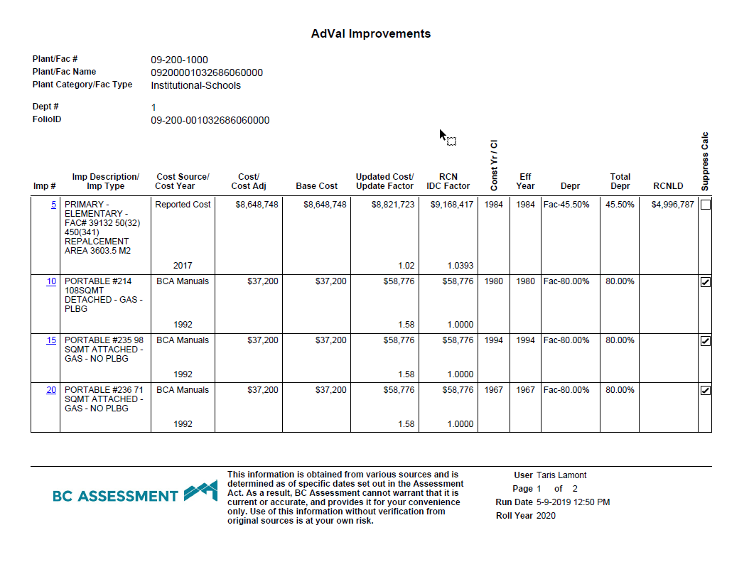

# Appendix B: Drill-Through # 2: AdVal Exemptions

